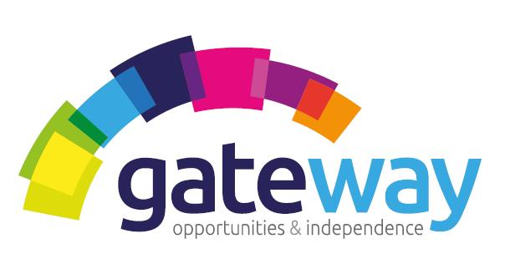

Gateway is an established charitable organisation which provides Outreach Care and Support and Supported Accommodations across Highland communities. Due to continued expansion we currently have the following exciting career opportunities.

SERVICE MANAGER

Are you a highly motivated, energetic, focused reliable individual with natural leadership qualities?
Are you passionate about making a difference to people lives?
Have you answered yes to both these questions? If so then you may have the qualities we are looking for.
We are currently recruiting for a Service Manager who can provide effective day to day support, guidance and supervision to a team of dedicated staff and Service Users in both a supported accommodation setting and in an Outreach capacity.
The successful candidate will be provided with full training and support to fulfil this role to meet the high care and support standards of the organisation and to meet the regulations of both the Care Inspectorate and the SSSC.
A driving licence is essential for this post and an SVQ 4 in Health and Social Care qualification is desirable but not essential.
For an Application Pack and further enquiries please contact Mrs Joanna Kennedy, Business Administrator on Tel No: 01463 718693.
Applications closing day is 7th December 2018.

