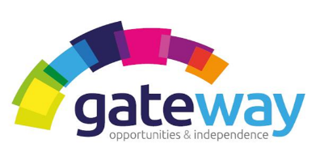

Gateway is an established charitable organisation which provides Outreach Care Support and Supported Accommodations across Highland communities. Due to continued expansion, we currently have the following exciting career opportunities.

OUTREACH SUPPORT WORKERS

Our services are expanding, and we are looking to recruit Support Workers to work as part of a team to provide support to promote independence and quality of life to vulnerable adults. Our teams provide support and care in supported living environments and to individuals in community settings. As a Support Worker you will be making a real difference to people’s lives, building strong relationships and assisting with daily living tasks.

If you are:
- A ‘people person’ who can build positive relationships with others– based on mutual respect and understanding, regardless of age, background or support needs;
- Able to communicate effectively and accurately in English, both spoken and written;
- Reliable, dedicated and able to meet the physical demands of the job;
- Available to work flexible shifts which includes weekends, evening and sleepovers;
- Interested in a rewarding career in social care – we would like to hear from you.

Applicants for the support workers posts will preferably have experience in the field of providing support and care and an SVQ qualification in Health and Social Care or equivalent or be prepared to work towards the necessary qualifications.

Driving licence necessary.

All posts require you to be a member of the Protecting Vulnerable Groups (PVG) Scheme and undertake the necessary vetting checks. Gateway has an extensive programme of professional development and an ongoing training programme that all staff have the opportunity to benefit from. Gateway implements an equal opportunity policy to promote diversity. Pay scales are variable according to experience and qualifications.

Salary – between £10.00 and £10.50, depending on qualifications and experience.
For an Application Pack and further details, please contact Joanna Kennedy on Tel No: 01463 718693

Closing date 7th of May 2021.

