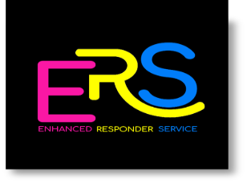

ENHANCED RESPONDER SERVICE
SPECIALISED SUPPORT WORKERS REQUIRED

Full time position - £12.00 per hour

Enhanced Responder Service is a unique and innovative service supporting the Care at Home Services within the Inverness area. This is a collaborative between four local and established care providers who are committed to its success.

We are looking for a team to deliver a mobile Enhanced Responder Service to clients, to be able to show compassion to the Inverness community and our people within it, show that you can work with dignity, respect, enthusiasm, demonstrating problem solving skills. You will be an experienced support worker to deliver personal care and support to vulnerable clients.

- A minimum of two years’ experience, specific to community care at home is essential.
- An awareness of post hospital discharge
- SVQ qualification in Health and Social Care SVQ3 – willingness to work towards it.
- Be able to deliver trusting and reliable support.
- Trained to meet SSSC registration standards.
- Hold a current UK driving licence, and access to own vehicle if required.
- The shift pattern will be on a fixed rotational basis, with the option of additional holiday and sickness cover.

We are looking for individuals who reflect the service core values –

- Compassion
- Respect
- Trust
- Empathy
- Responsible

For an application pack and further details, please contact Rebekah Brown, Administrative Assistant on Tel No. 01463 718693 or email to rebekah.brown@homelesstrust.org.uk

For informal discussion regarding the posts please contact Johanna Simpson on 07710304915.

Closing date for application is Sunday 6th June 2021.

