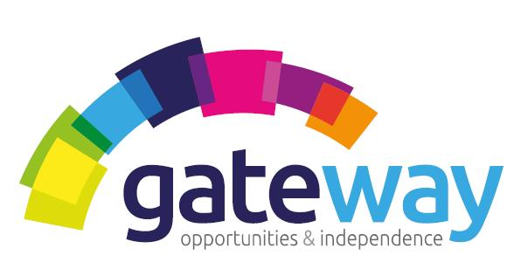
RESPECT|CARING| TRUST| EMPATHY| RELIABLE

We are currently seeking to recruit Full & Part Time Community Outreach Support Workers to join our team.

Position: Full and Part Time
Shifts: 8 am – 5 pm (Monday – Friday)
Salary: £19,760 - £20,748. p.a. pro rata (based on 38 hours per week)
Experience & Requirements
- Support Experience: Previous support experience is not essential as full training and mentoring will be provided before starting in the role. All we ask is that you have a friendly, caring, positive attitude, and a willingness to help those adults less able to remain in their own homes for as long as possible.
- You are able to build professional supportive relationships with your clients
- Personality: You should have a positive attitude and patience together with good verbal and written communication skills.
- You will be a team player and may help provide support flexibly to any of our clients
- Our Values: It’s vital that you align to our company values
- Availability: 8 am – 5 pm (Monday – Friday)
- Driving Licence: Essential due to locations.
Role of a Community Outreach Support Worker
- Our role is to provide housing support to members of the community to help them achieve their outcomes which can be highly diverse and varied. Our support packages are designed to provide person centred support; whether it is learning a new skill, becoming more involved in the community, a shopping trip, bird watching, or an evening out.
- Structured support packages are provided where we would be providing assistance with attending appointments, health eating choices, sign posting, accessing the community, getting involved in meaningful activities, and help and support to sustain their tenancies.
- You will develop and implement a person-centred support plan, agreed with the clients to help them achieve their outcomes. You will work independently, often lone working for long periods, providing support using a strength based approach You will be responsible for key working up to 8 clients as well as providing support responsively as and when required by other clients.
What do Gateway have to offer you?
- Full Time and Part Time contracted hours.
- Mileage allowance for using your own vehicle.
- Fully paid induction training, including shadowing and mentoring.
- Ongoing training and support.
- Work Pension Scheme.
- Fully paid PVG membership.
- The opportunity to sign up to Charity Workers discount scheme, Blue Light Card and Discount for Carers schemes.
About Gateway
Gateway is a Charitable Organisation established in 1998, that has a Gold Investors in People award. Our goal is to support vulnerable people in our community. Our aim is to provide a range of high-quality care services and activities that improves the well-being of the vulnerable people we support we achieve. For further an informal chat about the role please contact Chrissy Kemp, Service Manager on 07395887315 or for an application pack, please contact Rebekah Brown, Administrator on 01463 718693 or email rebekah.brown@homelesstrust.org.uk
http://www.homelesstrust.org.uk
Charity Number: SC02883

