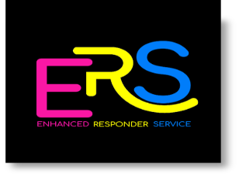
ENHANCED RESPONDER SERVICE
SPECIALISED SUPPORT WORKERS REQUIRED

Position: Full Time & Part Time
Shifts: 8am – 3pm / 4pm – 8pm or 4pm -10pm
Salary: £23,712 p.a. pro rata (based on 38 hours per week)
Enhanced Responder Service is a unique and innovative service supporting the Care at Home Services within the Inverness area. This is a collaborative between four local and established care providers who are committed to its success.
Gateway are looking for a support worker to work as part of a team who will deliver a mobile Enhanced Responder Service to clients, to be able to show compassion to the Inverness community and our people within it, show that you can work with dignity, respect, enthusiasm, demonstrating problem solving skills. You will be an experienced support worker who deliver personal care and support to vulnerable clients working closely with NHS Highland colleagues to support timely discharges from hospital.
- A minimum of two years’ experience, specific to community care at home is essential.
- An awareness of post hospital discharge
- SVQ qualification in Health and Social Care SVQ3 – or willingness to work towards it.
- Be able to deliver trusting and reliable support.
- Trained to meet SSSC registration standards.
- Hold a current UK driving licence, and access to own vehicle if required.
- The shift pattern will be on a fixed rotational basis, with the option of additional holiday and sickness cover.
What do Gateway have to offer you?
- Full Time and Part Time contracted hours
- Mileage allowance for using your own vehicle.
- Fully paid induction training, including shadowing and mentoring
- Ongoing training and support
- Work Pension Scheme
- Fully paid PVG membership.
- The opportunity to sign up to Charity Workers discount scheme, Blue Light Card and Discount for Carers schemes.
About Gateway
Gateway is a Charitable Organisation established in 1998, that has a Gold Investors in People award. Our goal is to support vulnerable people in our community. Our aim is to provide a range of high-quality care services and activities that improves the well-being of the vulnerable people we support we achieve.
For further an informal chat about the role please contact Johanna Simpson, Service Manager on 07710304915 or for an application pack, please contact Clare, Administrator on 01463 718693 or email recruitmement@homelesstrust.org.uk
http://www.homelesstrust.org.uk
Charity Number: SC02883

