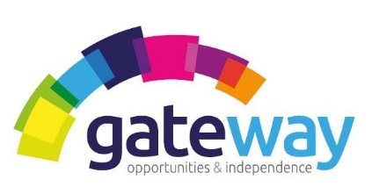

RESPECT|CARING| TRUST| EMPATHY| RELIABLE

We are currently seeking to recruit Full & Part Time Mental Health Support Workers to join our team.

Position: 1 x Full and 2 Part Time positions available
Shifts: Various (including weekends)
Salary: Up to £21,340. p.a. pro rata (based on 38 hours per week)

Role of a Mental Health Support Worker
- Provide holistic support to individuals living in Thistle House to help them achieve their goals. Our support packages are designed to provide person centred support; whether it is learning a new skill, maintaining independence, becoming more involved in the community, accessing benefits, health eating choices, a shopping trip, or meaningful activities of their choosing.
- Create an environment that promotes opportunities for service users to develop, learn and enable skills towards independence.
- Provide comprehensive support planning service to customers in line with the Gateway policies, procedures and approach.
- Ensure service users are fully informed of their rights and responsibilities regarding the service and are enabled and empowered to get involved in the running of the service through consultation and participation.
- Set up and maintain customer files and ensure that accurate and up to date records are kept of support provided to customers in accordance with Gateway policies.

Experience & Requirements
- Experience: Previous experience and understanding of Mental Health would
be advantageous but not essential as full training and mentoring will be provided before starting in the role.
- Understanding of Safeguarding adults.
- Knowledge and understanding of up to date legislation, government frameworks relevant to the client group.
- Ability to communicate effectively in writing including the preparation of reports & file notes.
- Personality: You should have a positive attitude and patience together with good verbal and written communication skills.
- You will be a team player and may help provide support flexibly to any of our clients
- Our Values: It’s vital that you align to our company values
- Availability: Flexible between 7am – 10pm

What do Gateway have to offer you?
- Full Time and Part Time contracted hours.
- Mileage allowance for using your own vehicle.
- Fully paid induction training, including shadowing and mentoring.
- Ongoing training and support.
- Work Pension Scheme.
- Fully paid PVG membership.
- The opportunity to sign up to Charity Workers discount scheme, Blue Light Card and Discount for Carers schemes.

About Gateway
Gateway is a Charitable Organisation established in 1998, that has a Gold Investors in People award. Our goal is to support vulnerable people in our community. Our aim is to provide a range of high-quality care services and activities that improves the well-being of the vulnerable people we support we achieve.
For further an informal chat about the role please contact Chrissy Kemp, Service Manager on 07395887315 or for an application pack, please contact Clare our Administrator on 01463 718693 or email recruitment@homelesstrust.org.uk
http://www.homelesstrust.org.uk
Charity Number: SC028837

